# Assignment 1(Stack)

1. Implementation of Stack & it's Functions (Push, Pop, Peek) + Check conditions of overflow & underflow (IsEmpty / IsFull) :

CODE :

#include <stdio.h>

#define MAX_SIZE 100

// Global Variables

int stack[100];

int top = -1;

int isEmpty()

{

    return (top == -1);

}

int isFull()

{

    return (top == MAX_SIZE - 1);

}

void push(int data)

{

    if (isFull())

    {

        printf("Stack Overflow/Full!\n");

        return;

    }

    stack[++top] = data;

    printf("%d pushed succesfully.\n", data);

}

int pop()

{

    if (isEmpty())

    {

        printf("Stack Underflow/Empty!\n");

        return -1;

    }

    int data = stack[top--];

    return data;

}

int peek()

{

    return stack[top];

}

void printStack()

{

    if (isEmpty())

    {

        printf("The Stack is empty, nothing to print!\n");

        return;

    }

    while (!isEmpty())

    {

        printf("%d\n", pop());

    }

}

int main()

{

    int data;

    int ch;

    printf("1 for push.\n");

    printf("2 for pop.\n");

    printf("3 for peek.\n");

    printf("4 for print stack.\n");

    printf("0 to exit.\n");

loop:

    printf("\nEnter operation to perform : ");

    scanf("%d", &ch);

    switch (ch)

    {

    case 1:

        printf("Enter data to push : ");

        scanf("%d", &data);

        push(data);

        goto loop;

    case 2:

        printf("%d poped succesfully.\n", pop());

        goto loop;

    case 3:

        printf("%d peeked.\n", peek());

        goto loop;

    case 4:

        printf("Your stack is :\n");

        printStack();

        goto loop;

    case 0:

        printf("Exited Successfully!!\n");

        break;

    default:

        printf("Error, Try again!!\n");

        goto loop;

    }

    return 0;

}

OUTPUT :

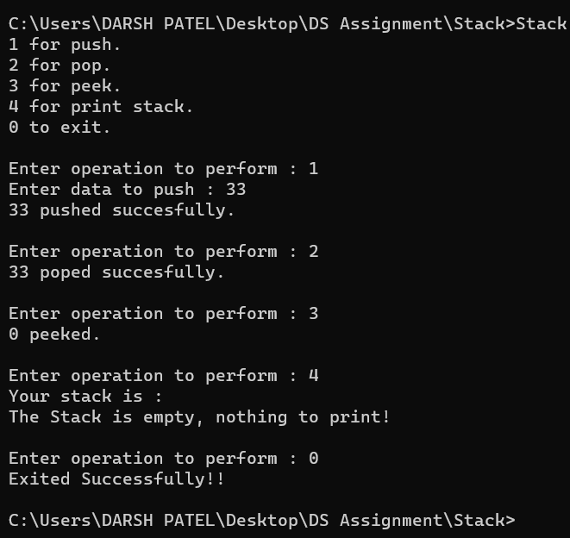

1. Implementation of Postfix notation.

CODE :

#include <stdio.h>

#include<string.h>

#include<stdlib.h>

#define MAX_STACK_SIZE 100

// Global Variables

char stack[100];

int top = -1;

int isEmpty()

{

    return (top == -1);

}

int isFull()

{

    return (top == MAX_STACK_SIZE - 1);

}

void push(char data)

{

    if (isFull())

    {

        printf("Stack Overflow/Full!\n");

        return;

    }

    stack[++top] = data;

}

char pop()

{

    if (isEmpty())

    {

        printf("Stack Underflow/Empty!\n");

        return -1;

    }

    char data = stack[top--];

    return data;

}

char peek()

{

    return stack[top];

}

void printStack()

{

    if (isEmpty())

    {

        printf("The Stack is empty, nothing to print!\n");

        return;

    }

    while (!isEmpty())

    {

        printf("%c\n", pop());

    }

}

int precedence(char operator)

{

    switch (operator)

    {

    case '+': case '-': return 1;

    case '*': case '/': return 2;

    case '^': return 3;

    default: return 0;

    }

}

int isOperator(char ch)

{

    if (ch == '+' || ch == '-' || ch == '*' || ch == '/' || ch == '^')

    {

        return 1;

    }

    return 0;

}

char *infixToPostfix(char *infix)

{

    int i,j=0;

    int len = strlen(infix);

    char *postfix = malloc(len+2);

    for ( i = 0; i < len; i++)

    {

        char ch = infix[i];

        if(ch == '(')

        {

            push(ch);

        }

        else if(ch==')')

        {

            while (peek()!='(')

            {

                postfix[j++]=pop();

            }

            pop();

        }

        else if(isOperator(ch))

        {

            while (!isEmpty() && precedence(peek())>=precedence(ch))

            {

                postfix[j++]=pop();

            }

            push(ch);

        }

        else

        {

            postfix[j++] = ch;

        }

    }

    while (!isEmpty())

    {

        if(postfix[j]=='(' || postfix[j]==')')

        {

            printf("The expression has a parenthesis error!!");

            return NULL;

        }

        postfix[j++] = pop();

    }

    postfix[j] = '\0';

    return postfix;

}

int main(int argc, char const *argv[])

{

    char *infix = malloc(MAX_STACK_SIZE-1);

    printf("Enter any expression in infix form : ");

    scanf("%s",infix);

    printf("Your Postfix expression is : %s",infixToPostfix(infix));

    return 0;

}

OUTPUT :

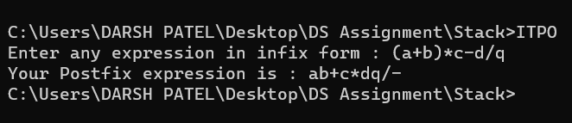

1. Implementation of Tower of Hanoi.

CODE :

#include <stdio.h>

#include <stdlib.h>

#define MAXSIZE 100

// Stack Structure

struct Stack

{

    int *arr;

    int top;

    char name;

};

// Creates a Stack

struct Stack initializer(char name, int size)

{

    struct Stack stack;

    stack.top = -1;

    stack.name = name;

    stack.arr = (int *)malloc(size * sizeof(int));

    return stack;

}

// Checks stack is full or not

int isFull(struct Stack *stack)

{

    return (stack->top == MAXSIZE - 1);

}

// Checks if Stack is Empty

int isEmpty(struct Stack *stack)

{

    return (stack->top == -1);

}

// Pushes data on top of Stack

void push(struct Stack *stack, int data)

{

    if (isFull(stack))

    {

        printf("Stack Overflow/Full!!\n");

        return;

    }

    stack->top++;

    stack->arr[stack->top] = data;

}

// Removes and Returns top data of Stack

int pop(struct Stack *stack)

{

    if (isEmpty(stack))

    {

        printf("Stack Underflow/Empty!!\n");

        return -1;

    }

    int data = stack->arr[stack->top];

    stack->top--;

    return data;

}

// Returns top data of Stack

int peek(struct Stack *stack)

{

    return stack->arr[stack->top];

}

// Prints Stack

void printStack(struct Stack *stack)

{

    while (!isEmpty(stack))

    {

        int data = pop(stack);

        printf("\n%d", data);

    }

    printf("\n");

}

// Add disks to Source Tower

void addDisksInSrc(int disks, struct Stack *src)

{

    while (disks)

    {

        push(src,disks--);

    }

}

// Tower of Hanoi Solver

void TowerOfHanoi(int disks, struct Stack *src, struct Stack *aux, struct Stack *dest)

{

    if (disks == 1)

    {

        printf("Move no. %d disk from %c to %c.\n", peek(src), src->name, dest->name);

        push(dest, pop(src));

        return;

    }

    TowerOfHanoi(disks - 1, src, dest, aux);

    printf("Move no. %d disk from %c to %c.\n", peek(src), src->name, dest->name);

    push(dest, pop(src));

    TowerOfHanoi(disks - 1, aux, src, dest);

}

// Main Function

int main(int argc, char const *argv[])

{

    int disks;

    printf("Welcome to Tower of Hanoi solver!\nHere,\nS means Source Tower,\nA means Auxilary Tower, \nD means Destination Tower.");

    printf("\nEnter no. of disks in tower of hanoi : ");

    scanf("%d", &disks);

    struct Stack src = initializer('S', MAXSIZE);

    struct Stack aux = initializer('A', MAXSIZE);

    struct Stack dest = initializer('D', MAXSIZE);

    addDisksInSrc(disks, &src);

    TowerOfHanoi(disks, &src, &aux, &dest);

    printf("Your Destination Tower after solving is :");

    printStack(&dest);

    return 0;

}

OUTPUT :

